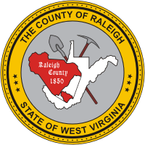

**Beginner Teacher Portfolio**

**Raleigh County Schools, West Virginia**